**CIVICS REVIEW: Our First Governments**

**Bell Ringer**. Answer the following questions below as your bell ringer today.

**1) The diagram below shows the influence of a historic document.**



**Which phrase completes the diagram?**

*A) All human beings possess certain natural rights.*

*B) Natural law is based on the exercise of human reason.*

*C) Government’s power needs to be limited and new taxes should be approved by the people’s representatives.*

*D) The best governments separate their powers into three branches.*

ANSWER: ____

**2) The diagram below shows that the colonists formed some of their political views from some historical documents.**

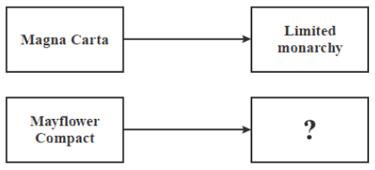

**Which phrase completes the diagram?**

*A) separation of powers*

*B) economic freedom*

*C) self-government*

*D) individual rights*

ANSWER: ____

**3) The diagram below describes a cause that led to the writing of the Declaration of Independence.**

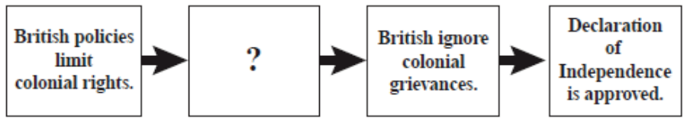

**Which action completes the diagram?**

*A) Colonial agriculture trade increases.*

*B) Colonial religious devotion increases.*

*C) Colonial demand for political change increases.*

*D) Colonial demand for military assistance increases.*

ANSWER: ____

**4) The passage below is from a historical document.**

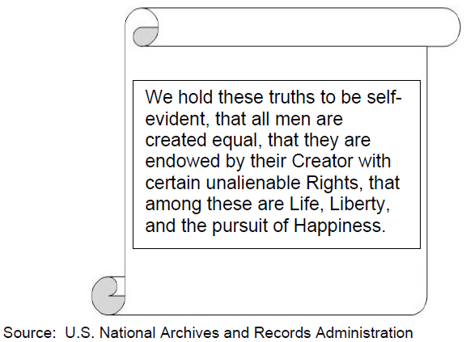

**Which document contains this passage?**

*A) Declaration of Independence*

*B) Articles of Confederation*

*C) English Bill of Rights*

*D) U.S. Constitution*

ANSWER: ____

**5) The diagram below provides details about an important historical event.**



**Which phrase completes the diagram?**

*A) The colonial theory of government*

*B) Montesquieu’s separation of powers*

*C) Grievances of the colonists against Britain*

*D) False rumors spread by colonial newspapers*

ANSWER: ____

**Part A: Reading and Response.** As a class, we will read through the “Wanted – A Just Right Government” PDF attached to this assignment. Answer the following questions as we go through the document.

|  |  |
| --- | --- |
| **QUESTION:** | **ANSWER:** |
| 1) What problem were Americans faced with after declaring independence and winning the Revolutionary War? |  |
| 2) True or false: The newly-independent Americans wanted a strong central government at first. |  |
| 3) The name of our first government was: |  |
| 4) How many branches of government existed under the Articles of Confederation? Which one was it? |  |
| 5) What were two of the good things about the Articles of Confederation? |  |
| 6) What were some of the problems with the Articles of Confederation? |  |
| 7) Why was it difficult to create a government that everyone would approve of? |  |
| 8) What was the Constitutional Convention? |  |
| 9) How many branches of government did the Constitution create? What are they? |  |
| 10) Today, Congress is a bicameral legislature (two parts). In which part of Congress does each state gets two votes no matter what its size? |  |
| 11) In the House of Representatives, how do we determine votes? |  |
| 12) The Articles couldn’t be changed unless all states agreed (unanimous). The Constitution can be changed if ______ of the states agree. |  |

**Part B. Multiple Choice**. Based on our reading and discussion, answer the following questions.

**13) Why did the Founding Fathers create a weak government under the Articles of Confederation?**

*A) They were afraid that states might lose their independence if the government were stronger.*

*B) They were worried that a strong central government might take away their rights.*

*C) They had a lot of complaints (grievances) under British rule, such as heavy taxes, and wanted a weaker government that could not engage in tyranny.*

*D) All of the above.*

ANSWER: ____

**14) Which of the following is true about the Articles of Confederation?**

*A) The Articles of Confederation divided up power between three branches.*

*B) The Articles of Confederation created a strong national government.*

*C) The Articles of Confederation created only a legislative branch.*

*D) The Articles of Confederation lasted for a long time.*

ANSWER: ____

**15) All of the following were problems with the Articles of Confederation EXCEPT for: ____**

*A) Congress could pass laws, but there was no president to enforce the laws.*

*B) The Articles could be easily changed and fixed, if needed.*

*C) Congress had no power to collect taxes.*

*D) The Articles did not create national courts, so there was no way to resolve conflicts between states.*

ANSWER: ____

**16) The Articles of Confederation saw states ignore laws passed by Congress. How did the new Constitution fix this problem?**

*A) It made it easier to amend, or change, the constitution.*

*B) It created three branches of government.*

*C) It limited the power of the president.*

*D) It divided our legislature into two parts: The House and the Senate.*

ANSWER: ____

**17) The diagram below shows defects in the Articles of Confederation and how they were corrected in the Constitution.**



**Which phrase completes the diagram?**

*A) Congress can raise an army.*

*B) The national government has the power to collect taxes.*

*C) The national government controls state tax collection.*

*D) The Supreme Court has the power of judicial review.*

ANSWER: ____

**18) Why did the Federalists believe the national government would not become too strong if the Constitution was adopted?**

*A) The people could only act through their representatives.*

*B) The federal government would use its powers to protect, not threaten, individual liberties.*

*C) Elected government officials could be trusted to protect individual rights.*

*D) A system of checks and balances would prevent the government from becoming tyrannical.*

ANSWER: ____

**19) How did the U.S. Constitution solve a problem created by the Articles of Confederation?**

*A) It avoided the issue of states' rights.*

*B) It allowed the states to elect representatives.*

*C) It prevented the amendment of federal laws.*

*D) It enabled the federal government to collect taxes.*

ANSWER: ____

**20) Which event completes the diagram?**

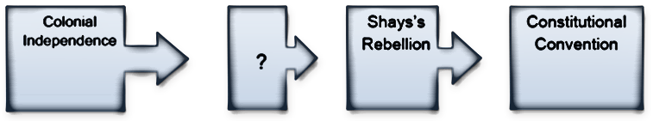

*A) Declaration of Independence*

*B) Articles of Confederation*

*C) Annapolis Convention*

*D) Whiskey Rebellion*

ANSWER: ____

**Part C. Free Response**. Based on our lesson and what you’ve learned this year in Civics, answer the following question. Use the PDF for evidence. Be as specific as you can.

**Why did the American colonists create a weak government with the Articles of Confederation? Why did they replace it soon after with a much stronger government? Give examples to explain your reasoning.**

ANSWER: